AI-Based Atmospheric Aerosol Prediction Using NASA MERRA-2 Data
Abstract
Atmospheric aerosols play a critical role in climate dynamics, air quality, and environmental monitoring. Accurate prediction of aerosol distribution can help improve climate modeling, pollution monitoring, and disaster preparedness. In this project, a machine learning system was developed to analyze and predict atmospheric aerosol concentrations using NASA's Modern-Era Retrospective Analysis for Research and Applications Version 2 (MERRA-2) dataset.
The dataset consists of 7306 NetCDF files covering approximately twenty years of atmospheric observations. Key aerosol variables including Black Carbon Mass Concentration (BCSMASS) and Dust PM2.5 Mass Concentration (DUSMASS25) were extracted and transformed into spatial tensors suitable for machine learning.
A deep learning convolutional neural network implemented in PyTorch was trained to learn spatial aerosol patterns and predict future aerosol distributions using historical data sequences. Training was performed using GPU acceleration on Google Colab.
The results demonstrate that deep learning models can successfully learn atmospheric spatial patterns and provide meaningful predictions of aerosol distribution. The developed pipeline also demonstrates how large climate datasets can be integrated with modern artificial intelligence techniques for environmental data analysis.

1. Introduction
Atmospheric aerosols are microscopic particles suspended in the Earth's atmosphere that originate from both natural and human-made sources. Natural sources include desert dust storms, volcanic eruptions, and sea salt aerosols, while anthropogenic sources include fossil fuel combustion, industrial emissions, and biomass burning.
These particles significantly influence atmospheric processes such as:
• Climate regulation
• Solar radiation absorption and scattering
• Cloud formation
• Air quality
• Human respiratory health
Predicting aerosol concentration patterns is therefore an important scientific challenge.
Traditional climate models rely on complex physical simulations and atmospheric chemistry models, which require significant computational resources. Machine learning methods provide an alternative approach capable of learning patterns directly from historical atmospheric datasets.
Recent advances in deep learning have enabled neural networks to learn complex spatial patterns from large datasets. Convolutional neural networks (CNNs), originally developed for image processing tasks, are particularly well suited for atmospheric datasets because aerosol maps resemble two-dimensional spatial images.
The goal of this project is to construct a machine learning system capable of analyzing aerosol data and predicting future aerosol distributions using deep learning methods.

2. Dataset Description
The dataset used in this project is the Modern-Era Retrospective Analysis for Research and Applications Version 2 (MERRA-2) dataset produced by NASA's Global Modeling and Assimilation Office (GMAO).
MERRA-2 is a global atmospheric reanalysis dataset that combines satellite observations with numerical weather models to produce consistent atmospheric data over long time periods.
Dataset Characteristics:
Dataset Name: MERRA-2 Aerosol Reanalysis
Product Code: M2T1NXAER
File Format: NetCDF4 (.nc4)
Temporal Coverage: 2003 – 2023
Total Files Downloaded: 7306
Spatial Grid:
Latitude Points: 141
Longitude Points: 145
Approximate Spatial Resolution: 0.5° × 0.625°
Each dataset file contains multiple atmospheric variables describing aerosol concentrations across the globe.

3. Aerosol Variables Used
Two important aerosol variables were selected for modeling:
1. BCSMASS – Black Carbon Mass Concentration
Black carbon aerosols are produced primarily from incomplete combustion processes such as:
• fossil fuel burning
• biomass burning
• industrial emissions
Black carbon strongly absorbs solar radiation and contributes significantly to global warming.

2. DUSMASS25 – Dust PM2.5 Mass Concentration
Dust aerosols originate mainly from desert regions and can travel long distances through atmospheric circulation.
Dust particles influence:
• atmospheric radiation balance
• cloud formation
• air quality
These two variables were selected because they represent both anthropogenic and natural aerosol sources.

4. Data Processing Pipeline
The raw atmospheric datasets were stored in NetCDF4 format, which is commonly used for scientific climate datasets.
To process the datasets, the Xarray Python library was used. Xarray provides an efficient interface for handling large multi-dimensional datasets.
The preprocessing pipeline consisted of the following steps:
- Load NetCDF dataset using Xarray
- Extract aerosol variables (BCSMASS and DUSMASS25)
- Convert spatial grids into numerical tensors
- Generate sequential training samples for the neural network

Example processing workflow:
ds = xr.open_dataset(file)
bc = ds["BCSMASS"].mean("time").values
du = ds["DUSMASS25"].mean("time").values
This converts the aerosol maps into 2-dimensional spatial arrays.

5. Feature Representation
The extracted aerosol maps were converted into tensors representing spatial atmospheric grids.
Tensor Shape:
(time, latitude, longitude, channels)
Example tensor:
(30, 141, 145, 2)
Where:
Channel 1 → BCSMASS
Channel 2 → DUSMASS25
These tensors represent aerosol concentration values across geographic coordinates.

6. Temporal Sequence Modeling
Atmospheric conditions evolve over time, so temporal information is important for accurate prediction.
To capture temporal dependencies, a sequence-based input representation was used.
Model Input:
Five previous days of aerosol maps
Model Output:
Predicted aerosol map for the next day.
Sequence representation:
t0, t1, t2, t3, t4 → predict t5
This allows the neural network to learn temporal evolution of aerosol distributions.

7. Data Normalization
Atmospheric aerosol values can vary over several orders of magnitude. To stabilize neural network training, a logarithmic transformation was applied.
Transformation used:
log(1 + value × 10⁹)
This transformation compresses extreme values and improves model convergence during training.

8. Machine Learning Model
A convolutional neural network (CNN) was implemented using the PyTorch deep learning framework.
CNNs are well suited for spatial data because they learn local spatial patterns using convolution filters.
Model Architecture:
Conv2D (10 → 32)
ReLU activation
Conv2D (32 → 16)
ReLU activation
Conv2D (16 → 2)
Input Channels:
5 time steps × 2 aerosol variables = 10 channels
Output Channels:
2 predicted aerosol maps.

9. Training Setup
The neural network was trained using the following configuration:
Optimizer: Adam
Loss Function: Mean Squared Error (MSE)
Learning Rate: 0.001
Training Epochs: 10
Hardware Platform: Google Colab
GPU: NVIDIA Tesla T4
GPU acceleration allowed efficient training on high-dimensional spatial climate data.

10. Results and Visualization
Several visualization techniques were implemented to analyze both the dataset and model performance.
Generated visualizations include:
• Aerosol spatial heatmaps
• Prediction vs ground truth comparisons
• Residual error maps
• Aerosol value distribution histograms
• Dataset temporal coverage plots
• Training loss curves
These visualizations provide insight into how the neural network interprets atmospheric aerosol patterns.

Figures
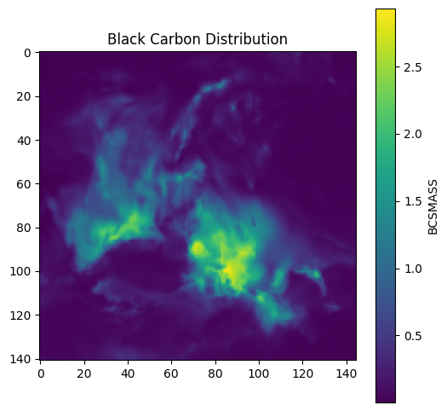
Figure 1 – Black Carbon Aerosol Distribution Map
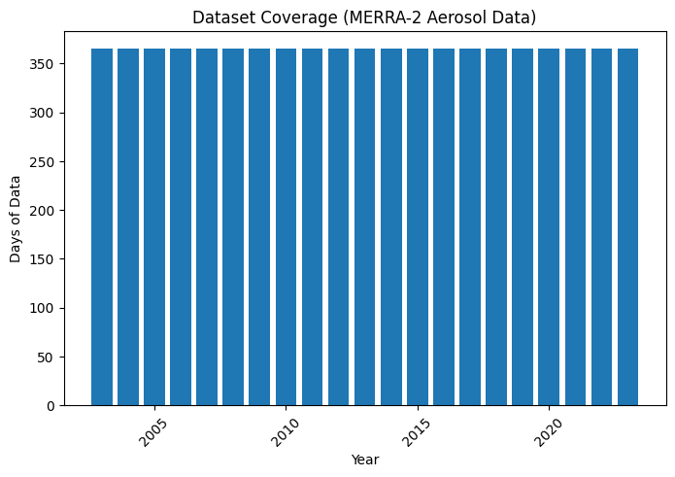
Figure 2 – Dust PM2.5 Aerosol Distribution Map
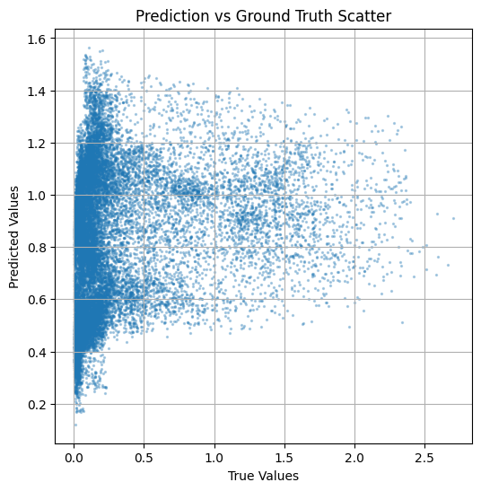
Figure 3 – Prediction vs Ground Truth Scatter Plot

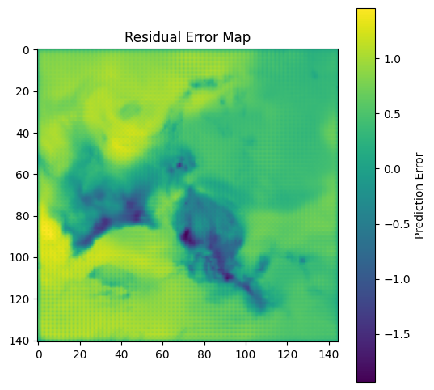
Figure 4 – Residual Error Map

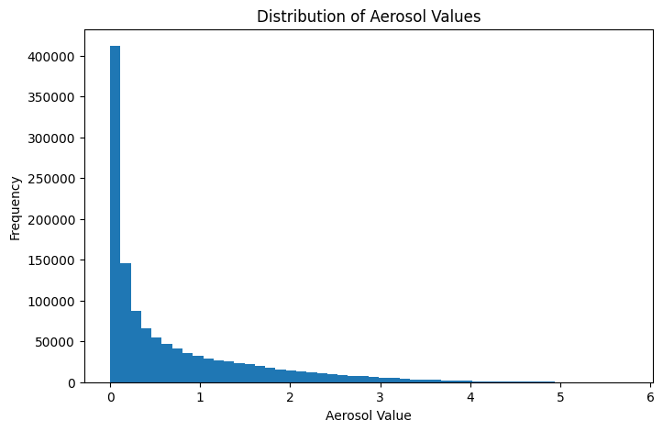
Figure 5 – Aerosol Value Distribution Histogram

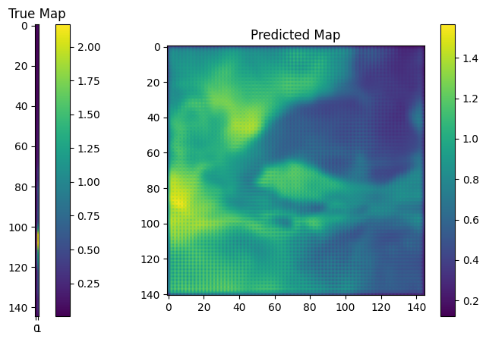
Figure 6 – Ground Truth vs Predicted Map Comparison
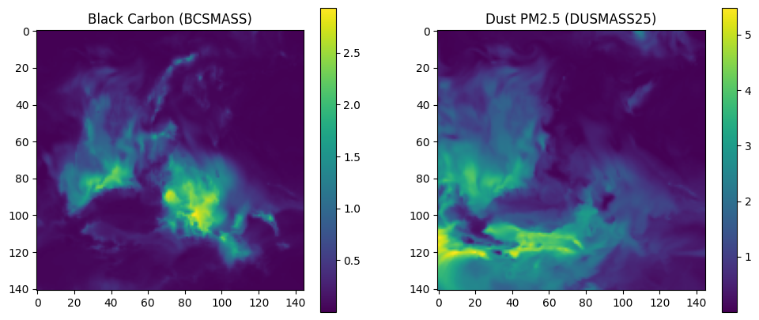
Figure 7 – Dataset Black Carbon & Dust PM2.5
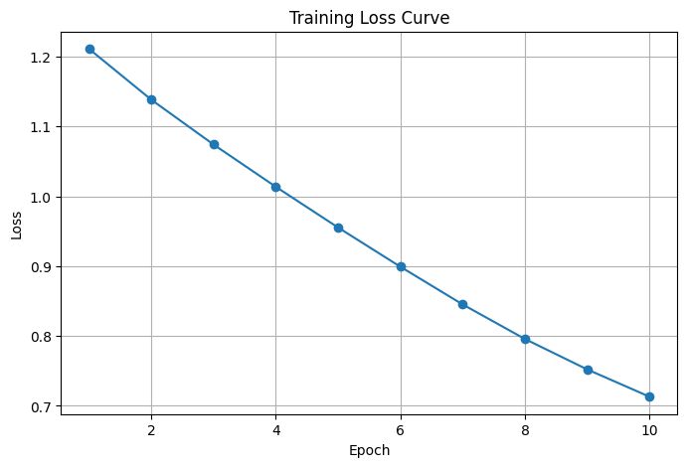
Figure 8 – Model Training Loss Curve

11. System Capabilities and Contributions
The developed system demonstrates a complete machine learning pipeline for atmospheric aerosol prediction using long-term climate datasets.
The key capabilities of the developed system include:
Large-scale atmospheric dataset processing
The system successfully processes a long-term atmospheric dataset consisting of 7306 NetCDF files spanning approximately 20 years of observations.
Spatiotemporal data modeling
The implemented neural network architecture learns spatial relationships between atmospheric aerosol variables across geographic grids while incorporating temporal dependencies.
Automated preprocessing pipeline
A fully automated preprocessing pipeline was developed to convert raw NetCDF atmospheric datasets into machine learning tensors.
GPU-accelerated training
The model training was performed using GPU acceleration, allowing efficient learning from high-dimensional atmospheric grids.
Visualization and interpretability
Multiple visualization techniques were implemented to interpret both dataset characteristics and neural network predictions.
Prediction capability
The trained neural network is capable of predicting aerosol spatial distributions based on historical atmospheric conditions.

12. Conclusion
This project demonstrates the successful integration of atmospheric science datasets with modern machine learning techniques. By processing large-scale climate datasets and applying deep learning models, the system learns spatial aerosol patterns and predicts future aerosol distributions.
The developed pipeline demonstrates how artificial intelligence can be applied to environmental data analysis and climate research.
Machine learning approaches such as convolutional neural networks provide a powerful alternative to traditional atmospheric modeling techniques by learning directly from historical data.
The results of this project highlight the potential of deep learning methods for atmospheric science applications, including:
• air quality monitoring
• climate data analysis
• aerosol prediction
• environmental forecasting
The developed system represents a promising step toward integrating artificial intelligence with climate research for improved environmental understanding.

